# MSD Intended Design for Smart Search & Navigation

## I - Smart Search

### Flags/Indicators:

Firstly, let’s go through the flags and additional information we would want like to be included in the person search results listed under the Smart-Search.

Refer the screen shot below for different flags and information that gets displayed in the regular (traditional) Person search results.

For example,

1. Prospect Person
2. Special Caution
   1. While hovered over, displays a brief about the caution (ex. Staff-Security, Public-Risk)
3. Duplicate
4. Secured
5. Must View Alert
   1. While hovered over, displays a brief about list of notes, etc. (ex. IRD Change, Agent Update)

We would like to **have these** **indicators in the Smart-Search results as well**.

Please assume that a trimmed version of below screenshot (Existing Person Search results) would appear in the smart search result.

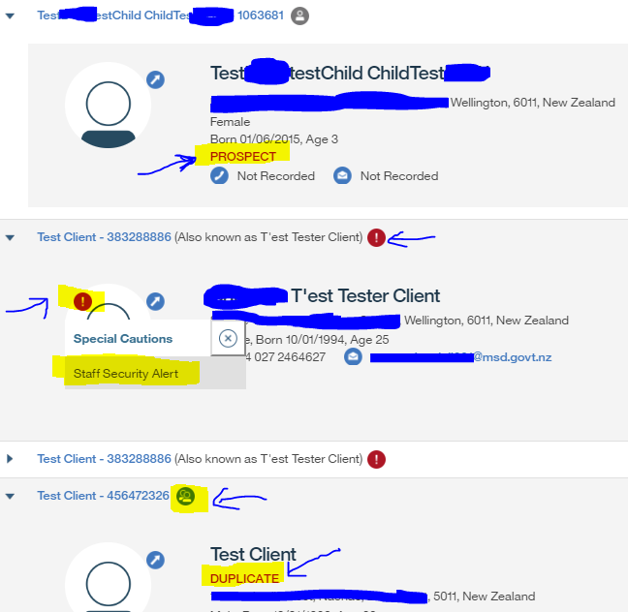

## II - Smart Navigation:

Firstly, let’s go through the ‘existing’ application/process flow to understand the steps involved in it.

For Example,

**Caseworker’s task/process**: Review ‘Assessments’ for the client, “Testing Test”

**Steps involved**:

Below is the list of steps/actions the caseworker would go through before attempting to “review Assessments”

1. Search for the client “Testing Test” through traditional Person-Search
2. Select the client “Testing Test” from the result
3. System displays Person-home page (PDC home) "**at background**" as a **new tab** with a "**Modal-Window**" containing critical information on top of it. Note: Person-home page is inactive
4. Acknowledge the information in Modal-Window
5. System closes the Modal-Window
6. System activates the Person-Home page – which has other links for further process
7. Select the link, "Service Delivery Case" – which is the Integrated Case (IC) for client, Testing Test
8. System displays the ServiceDeliveryCase(IC)-Home page as a new tab
9. Select the in-page tab, ‘Assessments’ within the IC page
10. System displays the Assessments page within IC case
11. Review the Assessment for the client, Testing Test.

Please note that there is 1 important step the caseworker should have performed after searching the client i.e., acknowledging the information (step#4) before reviewing the assessment (step#11)

### Screen-Flow:

Refer below screen-flow which depicts the above steps.

Assume that steps 1 & 2 are performed i.e., caseworker has selected the client, “Testing Test”

Step#3 System renders Person-Home in a tab but disabled with a Modal-Window containing cautions on top.

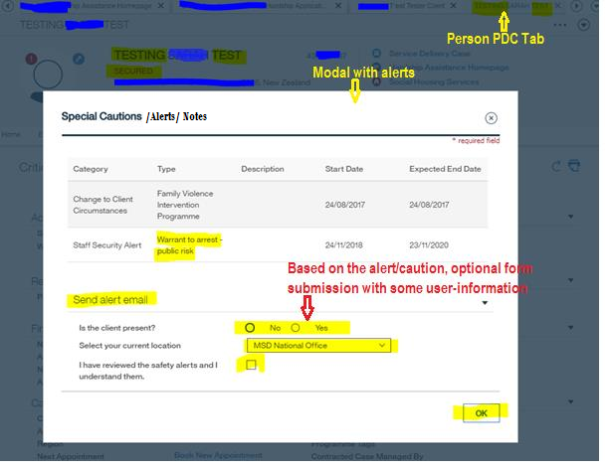

User acknowledged the caution with an option to email as in Step#4

System closes the modal and activates the person home – Step#5

Step#6 Person-Home becomes active

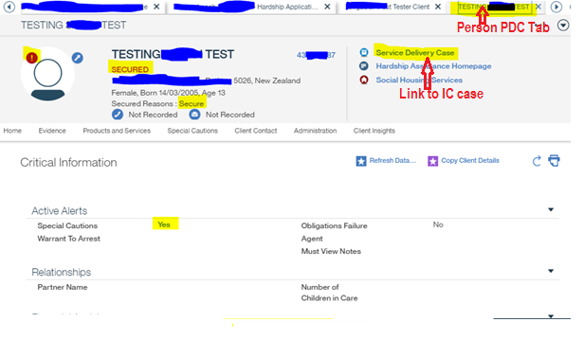

User selects ‘Service Delivery Case’ link – to IC (Step#7)

Step#8 IC tab is displayed in a separate tab

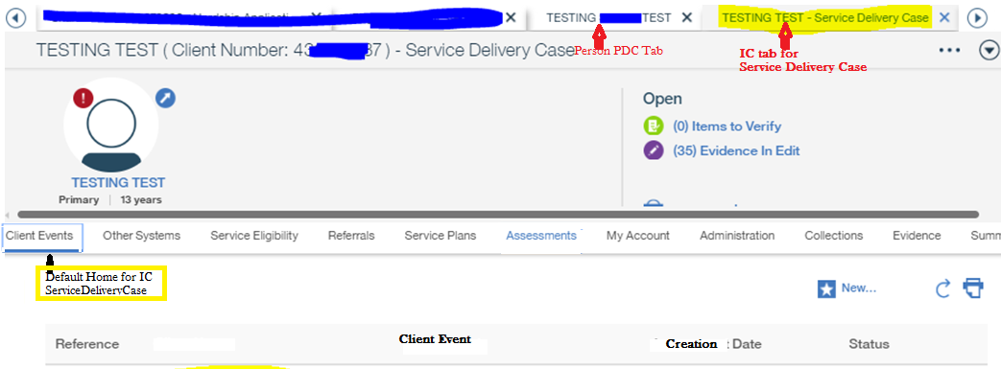

User selects ‘Assessments’ link (Step#9)

Step#10 Assessments page is displayed

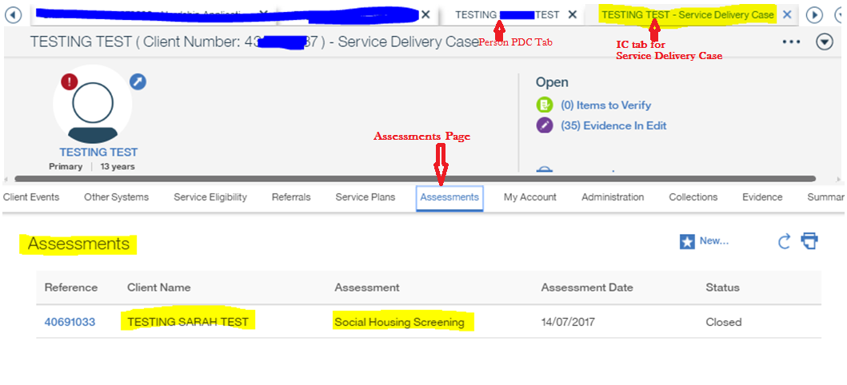

**Potential Option – Smart Nav (1 among few options)**

We think one of the options to achieve the above requirement could be as below (pseudo design)

1. User enters person name and the action-keyword (ex. screen-name like assessments) to navigate to
2. System (smart nav feature) does the search and returns the list with indicators against individual item (ex. existence of alerts)
   1. API to return the list should be extendable/customisable
3. System renders the list with all items taking to **same** URL (generic-resolver) but with different parameters
   1. List of parameters should extendable and/or customisable
4. System redirects to a generic-resolver passing the targetURL and other flags as parameters
5. Generic resolver redirects to (based on the parameters and/or any Server call) either
   1. A generic page
      1. Generic page which will be displayed in a Modal-Window – if any flag exist/ condition passed
      2. System passes the target URL to the generic modal page
      3. On user acknowledgement, the modal window gets closed and the system redirects to the targetURL passed as parameter
         1. Target page is displayed in its appropriate tab separately
      4. Alternatively, the modal page could also have separate links (Optionally)
         1. Those links within the modal window should open a separate modal-window on top of it (which in turn would/should not have any further links). This could be implemented in few other ways but we understand that it could lead to issues/have limitations.
         2. The original modal window (with cautions and alerts) shouldn’t be closed until its form is submitted
   2. Target page is displayed in its appropriate tab – if NO flag exists/condition fails
      1. No page/tab gets opened in the background

Please refer below screen flow that tries to depict the above steps.

**Step#1** User enters the client name and keyword ‘Assessments’ in Smart field

System displays the list with the link displayed as ‘Assessments’

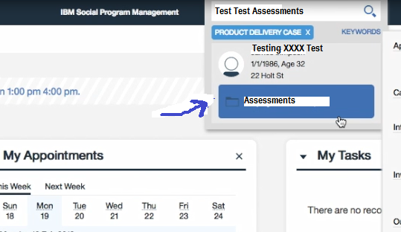

**Step#2** User selects Assessments for the client, Testing XXXX Test

System displays a modal/popup (always same generic page)

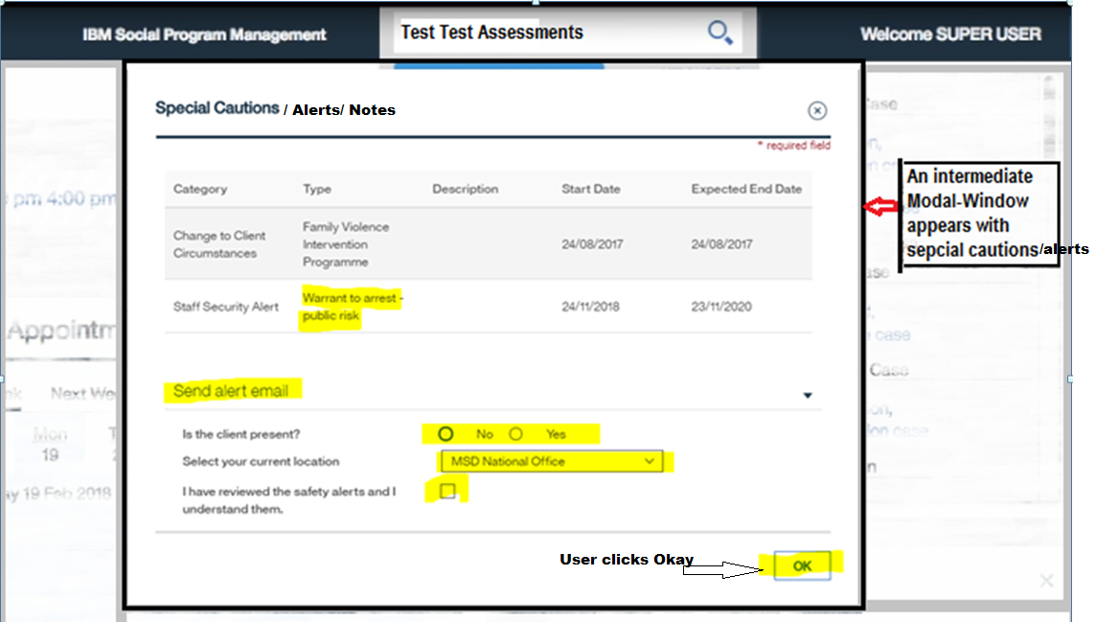

**Step#3** User reviews the cautions and submits the form by clicking ‘Ok’

System closes the modal window and displays the Assessments page in its own tab (as defined in the global tab config.

Please note that

* the Person Home (PDC) page/tab is not opened
* IC (SDC) tab is opened but taken directly to Assessments page

